**2.2.8. Chosen Framework**

choosing the right framework for software creation is one of the most important steps toward making good software due to the importance of the frameworks, it controls the application reliability and programming and testing efforts [23]. So, it will be important to choose the right framework wisely.

Every framework has its advantages and disadvantages, but there are still some core topics that we consider when we choose the framework for our software.

The following three factors were taken into account when selecting the framework for our software project:

* **Documentation**: Essential point as a good documentation means a better explanation on how everything works inside the framework and that will lead to a better implementation and use of the framework functionality.
* **Security**: Effective and reliable framework security is very important to any software because it protects the user's personal data and prevents it from being stolen [24].
* **Community Support**: the framework must have an active community of support. This is important to find a solution if we have any problems while implementing the software or we couldn’t find it in the documentation[26].

The Educational Game Design Framework is focused on producing

games that combines three main factors: game design, pedagogy and learning content modeling, Here is a list of the frameworks that we will choose from [38].

1. **Unity**

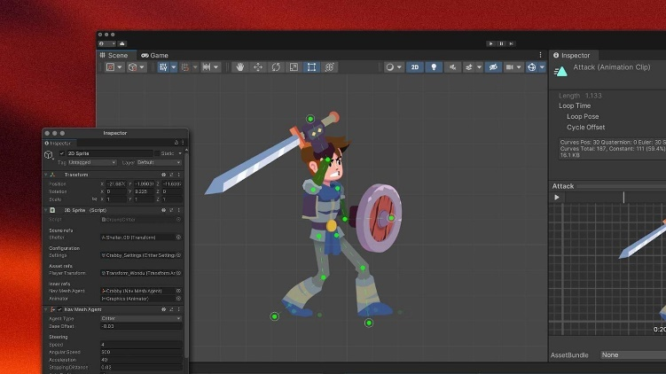It prides itself being a cross-platform game engine supported on Android, iOS and Linux. You can develop in a language of your choice consisting of C#, Boo or JS. It allows you to build game styles of 2D,3D, virtual reality and augmented reality. It’s flexible and well documented. Unity is a popular development platform and has an excellent support service offering many tutorials and guides, also there is a free version [36].

1. **UnrealEngine**

Is a framework which requires no additional plug-ins. Unreal contains pre-built modular systems and customizable plug-ins. Its code is written in C++ and runs on over ten platforms. Similarly, it allows you to create virtual and augmented reality-style games [37].

1. **libGDX**

It is a free, open-source, cross-platform framework. Licensed under Apache 2 you can build 2D or 3D games using Java as well as using some C++ and C components. It allows you to create games using the same code base for Linux, macOS, Windows, HTML5, Android, iOS and Blackberry. Therefore as a developer, you can write, test and debug your application. There is ever-growing community support with many tutorials provided by them and third parties.

1. **GODOT**

An open-sourced and free cross-platform framework operating under the MIT license. GODOT allows for the construction of 2D and 3D games. Its games are built-in the C# or C++ language made for mobile, PC and web platforms. Similarly, it also has its own language if you choose to use GDScript. Currently, the platforms it supports are HTML5, iOS, macOS, Android, Windows, Blackberry 10 and many others. Alongside the code, GODOT features an animation system which has a range of original features [35].

Now our final choice fell on the duo Unity and Unreal Engine and now we will make a more accurate comparison for the final selection.

Finally, We chose Unity framework to implement our software project because of its huge benefits as:

* Easy to learn
* The engine is actively developing and getting more and more features each release.
* Huge range of supported platforms
* One of the biggest communities
* A lot of ready-to-use solutions and assets.

Also using the same code to many platforms, it reduces the cost and complexity of the app production while accelerating app development.

